# Density of data points

import warnings
warnings.filterwarnings("ignore")

import numpy as np
import pandas as pd
import matplotlib.pyplot as plt
import sklearn.preprocessing
import random

import keras
from keras.models import Sequential
from keras.layers import Dense

POINT_N = 1000
DIM_N = 2

data0 = pd.read_csv("./class_splash_3_w100_PCA.csv", sep=',')
print("Info of the data:", data0.info())
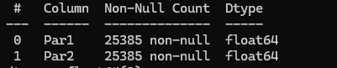
data0 = data0.to_numpy(copy=True)
scaler = sklearn.preprocessing.MinMaxScaler((-1.0, 1.0))
data0 = scaler.fit_transform(data0)

data = np.empty([POINT_N, DIM_N])
for i in range(POINT_N):
data[i] = data0[random.randrange(0, data0.shape[0])]
plt.figure(figsize=(8, 8))
for n in range(len(data)):
plt.scatter(data[n][0], data[n][1], c='blue', marker='o')
plt.show()
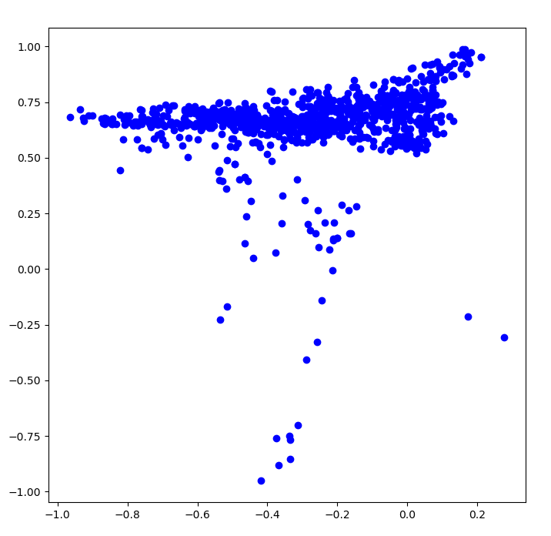
# ---------------------------------------------------------------------------------------------
model = Sequential()
model.add(Dense(30, input_dim=DIM_N, activation='relu'))
model.add(Dense(2, activation='softmax'))

opt = keras.optimizers.RMSprop(learning_rate=.001, momentum=0.9)
model.compile(loss='mse', optimizer=opt, metrics=['accuracy'])

eps = 0.0001
err = 1.0e+99
data1 = np.empty([POINT_N, DIM_N])
DD = int(2.5 * data1.shape[0])
iter = 0
while iter < 1000:
iter += 1

for i in range(POINT_N):
data1[i] = data0[random.randrange(0, data0.shape[0])]
data = data1[:, 0:DIM_N]
data = np.concatenate((data, np.zeros((data.shape[0], 1))), axis=1)

data_noise = np.random.rand(DD, DIM_N) * 2.0 - 1.0
data_noise = np.concatenate((data_noise, np.ones((DD, 1))), axis=1)

data = np.concatenate([data, data_noise], axis=0)
np.random.shuffle(data)

x = data[:, 0:DIM_N]
y = data[:, DIM_N].astype(int)
y = keras.utils.to_categorical(y, num_classes=2)

if iter == 1:
plt.figure(figsize=(8, 8))
for n in range(len(x)):
plt.scatter(x[n][0], x[n][1], c=('blue' if y[n][0] == 0 else 'red'), marker='o')
plt.show()
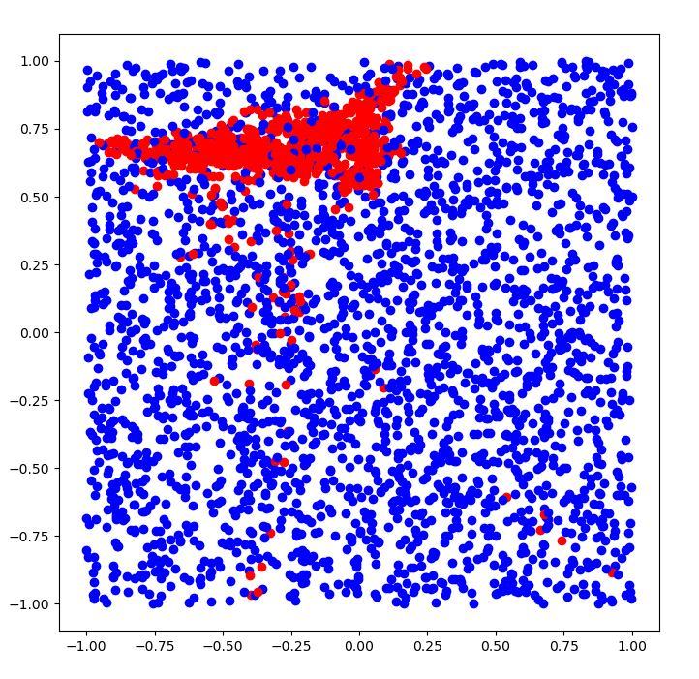
hist = model.fit(x, y, batch_size=100, epochs=1, verbose=0)
if abs(hist.history['loss'][0] - err) < eps and iter > 100:
break
err = hist.history['loss'][0]
print('***** ', iter, ' - ', err)

# -----------------------------------------------------------------------------------------------

xx = np.empty([3*POINT_N, DIM_N])
for i in range(3*POINT_N):
xx[i] = data0[random.randrange(0, data0.shape[0])]

pred = model.predict(xx)
res = np.argmax(pred, axis=1)
plt.figure(figsize=(8, 8))
for n in range(len(xx)):
plt.scatter(xx[n][0], xx[n][1], c=('blue' if res[n] == 0 else 'red'), marker='o')
plt.show()
a = 1.0 - np.sum(res)/len(xx)
print("\n", "Accuracy of the dataset", a)
