model=Sequential()
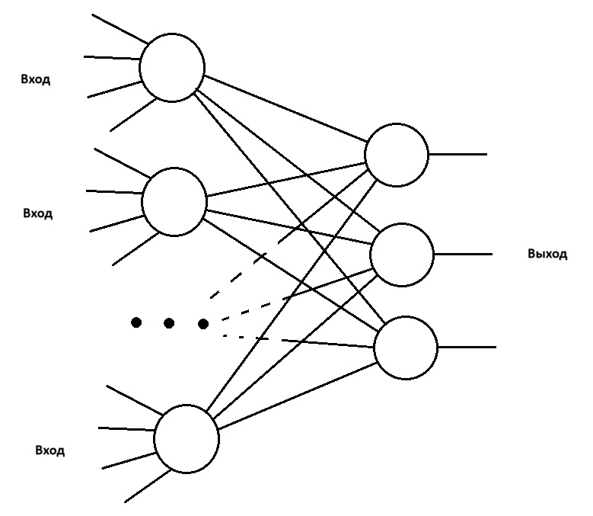
model.add(Dense(20, input_dim=4, activation='relu'))
model.add(Dense(3,activation='softmax'))

import warnings
warnings.filterwarnings("ignore")

import pandas as pd
import seaborn as sns
import matplotlib.pyplot as plt
import numpy as np
from sklearn import preprocessing

data=pd.read_csv("../Iris.csv")
print("Info of the data:",data.info())
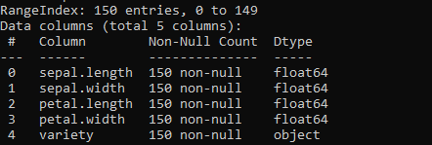
columns = data.columns.tolist()[0:4]
sns.pairplot(data[columns])
plt.show()

data=data.loc[np.random.permutation(len(data))]

enc = preprocessing.OneHotEncoder(handle_unknown='ignore')
enc_data = enc.fit_transform(data[["variety"]]).toarray ().astype(int)
data.drop("variety", axis= 1 , inplace= True )

data[["c1","c2","c3"]] = enc_data
print("Info of the data:",data.info())
print(data.head())
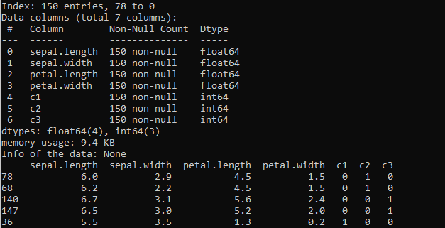
# Converting data to numpy array in order for processing
x=data.iloc[:,0:4].values
y=data.iloc[:,4:7].values

x_normalized=preprocessing.normalize(x,axis=0)

total_len=len(data)
train_len=int(0.8*total_len)
test_len=int(0.2*total_len)

x_train=x_normalized[:train_len]
x_test=x_normalized[train_len:]
y_train=y[:train_len]
y_test=y[train_len:]

#Neural network module
import keras
from keras.models import Sequential
from keras.layers import Dense

model=Sequential()
model.add(Dense(20, input_dim=4, activation='relu'))
model.add(Dense(3,activation='softmax'))

model.compile(loss='mse', optimizer='adam')

callback = keras.callbacks.EarlyStopping(monitor="loss", mode="min", verbose=1, patience=100, min_delta=0.01)
history=model.fit(x_train, y_train, epochs=1000, verbose=1, callbacks=[callback])
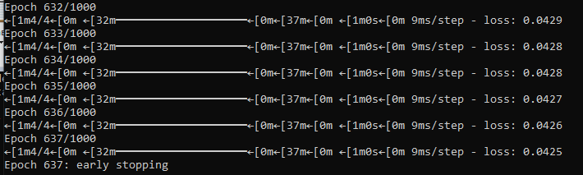
plt.plot(history.history['loss'], color='b', label="validation loss")
plt.xlabel("Number of Epochs")
plt.ylabel("Loss")
plt.legend()
plt.show()
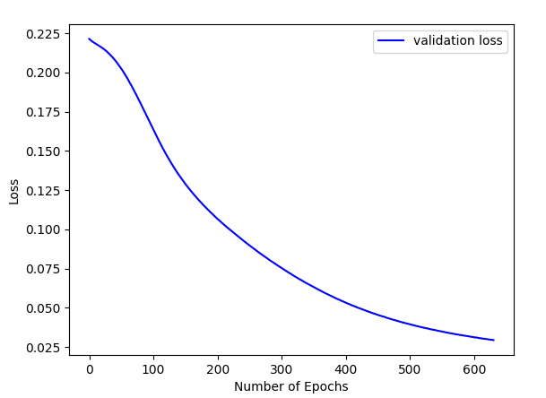
prediction=model.predict(x_test)
print(prediction[0:5,:])
print(y_test[0:5,:])
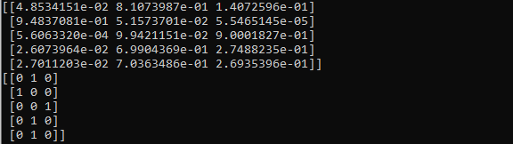
y_label=np.argmax(y_test,axis=1)
predict_label=np.argmax(prediction,axis=1)

accuracy=np.sum(y_label==predict_label)/test_len * 100
print("Accuracy of the dataset",accuracy )

