import numpy as np
import matplotlib.pyplot as plt
from sklearn import datasets

POINT_N = 300
DIM_N = 2
CLUST_N = 3

data, targ = datasets.make_blobs(n_samples=POINT_N, centers=CLUST_N, cluster_std=[0.5,1.5,1.5], n_features=DIM_N, center_box=(-10,10), random_state=0)

plt.figure(figsize=(5,5))
for i in range(POINT_N):
if targ[i]==0:
plt.scatter(data[i][0], data[i][1], c='blue', marker='o')
else:
if targ[i]==1:
plt.scatter(data[i][0], data[i][1], c='green', marker='o')
else:
plt.scatter(data[i][0], data[i][1], c='magenta', marker='o')
plt.show()

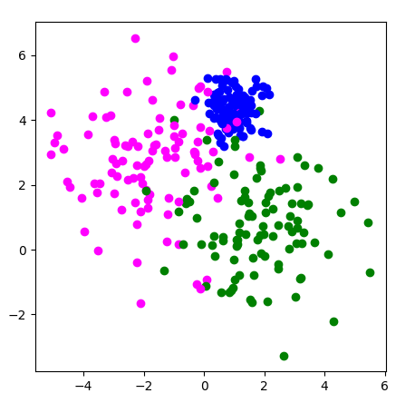

#Neural network module
import keras
from keras.models import Sequential
from keras.layers import Dense

model=Sequential()
model.add(Dense(20, input_dim=DIM_N, activation='relu'))
model.add(Dense(20, activation='relu'))
model.add(Dense(1,activation='linear'))
model.compile(loss='mse', optimizer=keras.optimizers.Adam(learning_rate=0.001))

callback = keras.callbacks.EarlyStopping(monitor="loss", mode="min", verbose=1, patience=30, min_delta=0.003)
history = model.fit(data, targ, batch_size=32, epochs=300, verbose=1, callbacks=[callback])

res = model.predict(data)

for n in range(10):
print (targ[n],"-",res[n])

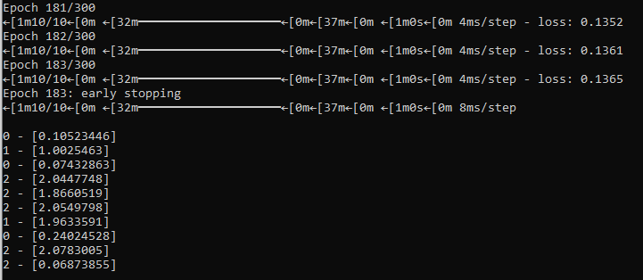
plt.plot(history.history['loss'], color='b', label="validation loss")
plt.xlabel("Number of Epochs")
plt.ylabel("Loss")
plt.legend()
plt.show()
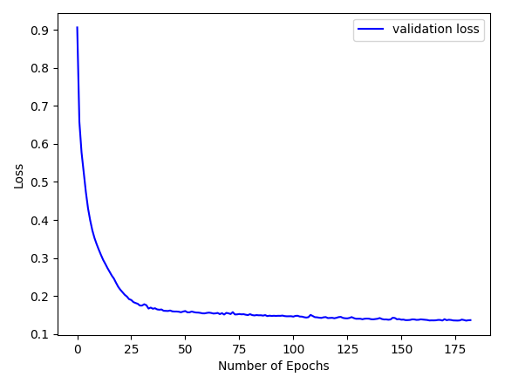

plt.figure(figsize=(5,5))
for i in range(POINT_N):
if res[i]<0.5:
plt.scatter(data[i][0], data[i][1], c='blue', marker='o')
else:
if res[i]<1.5:
plt.scatter(data[i][0], data[i][1], c='green', marker='o')
else:
plt.scatter(data[i][0], data[i][1], c='magenta', marker='o')
plt.show()
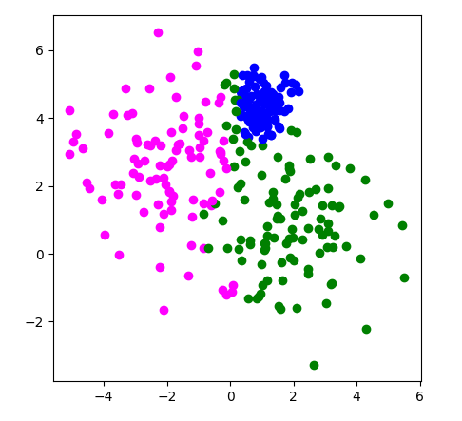
plt.figure(figsize=(7,5))
plt.hist(res, bins=15*CLUST_N, color='blue')
plt.show()
