Nigeria: An Overview and Fascinating Facts
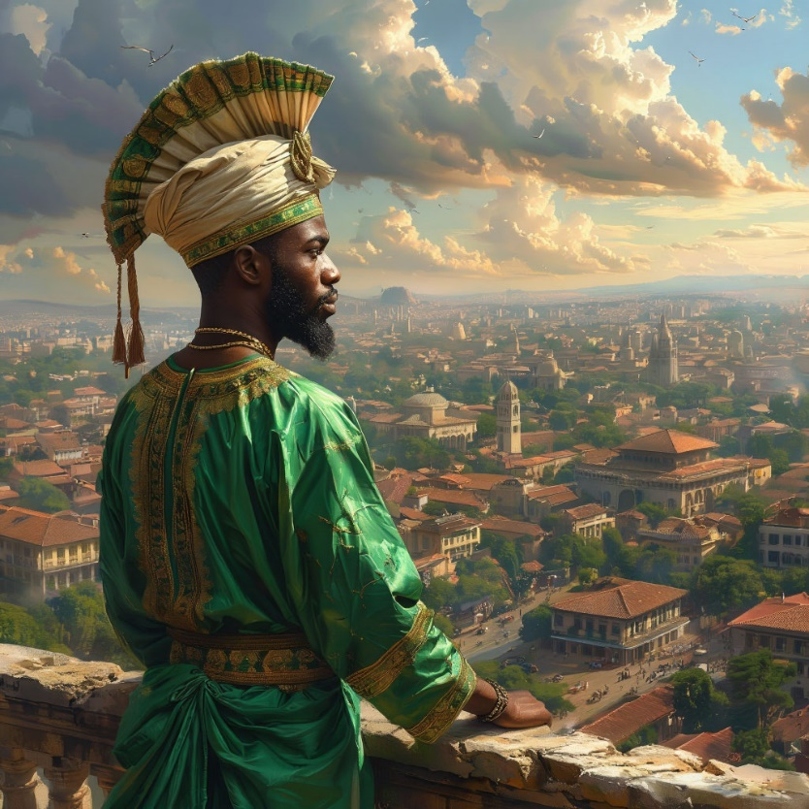

1. Introduction to Nigeria
Nigeria, officially the Federal Republic of Nigeria, is a vibrant country in West Africa. It is often called the “Giant of Africa” due to its large population, diverse culture, and booming economy. With over 230 million people, it is the most populous country in Africa and the 7th most populous in the world.

Capital: Abuja
Largest City: Lagos (one of the fastest-growing megacities globally)
Official Language: English (with over 500 indigenous languages spoken, including Hausa, Yoruba, and Igbo)
Currency: Nigerian Naira (₦)

Historical Context: Nigeria gained independence from British colonial rule in 1960. Since then, it has navigated periods of military rule and democracy, with its current constitution adopted in 1999.

2. Geography and Climate
Nigeria’s landscape ranges from tropical rainforests in the south to savannas and the semi-arid Sahel in the north. Key features include:

Niger River: The country’s lifeline, flowing through the interior.

Chappal Waddi: The highest peak (2,419 meters) in the Mambilla Plateau.

Gurara Falls: A stunning waterfall in Niger State (ideal image spot).

The climate is tropical, with a rainy season (April–October) and a dry season (November–March).

Natural Resources: Nigeria is rich in oil, natural gas, and minerals like tin and columbite. However, environmental challenges like deforestation and oil spills in the Niger Delta remain critical issues.

3. Cultural Diversity
Nigeria is home to 250+ ethnic groups, each with unique traditions:

Yoruba: Known for festivals like the Eyo Festival in Lagos.

Hausa-Fulani: Dominant in the north, famous for Durbar horseback parades.

Igbo: Celebrated for the New Yam Festival (Iri Ji).

Religion: A mix of Islam (north), Christianity (south), and indigenous beliefs.

Cultural Heritage: Traditional crafts like Adire (indigo-dyed cloth) and Calabash carvings reflect Nigeria’s artistic legacy. Music and dance play pivotal roles in ceremonies, with instruments like the talking drum and shekere (gourd rattle) used across ethnic groups.

4. Economy: Africa’s Powerhouse
Nigeria has the largest economy in Africa (GDP: ~$500 billion), driven by:

Oil Production: Accounts for 90% of export earnings.

Agriculture: A major employer; Nigeria is the world’s largest producer of cassava.

Tech Hub: Lagos’ “Yabacon Valley” is a hotspot for startups like Flutterwave.

Economic Challenges: Despite wealth from oil, Nigeria faces issues like currency devaluation, corruption, and reliance on imports. Efforts to diversify include promoting renewable energy and digital innovation.

5. Fascinating Facts
a) Nollywood: The Film Giant
Nigeria’s film industry, Nollywood, produces over 2,500 movies annually—second only to India’s Bollywood. Films often tackle social issues and are filmed on low budgets (add Nollywood image).

b) Musical Influence
Afrobeats, a genre blending traditional rhythms with modern pop, has gone global thanks to stars like Burna Boy and Wizkid.

c) UNESCO Sites
Sukur Kingdom: A UNESCO-listed cultural landscape with ancient iron-smelting traditions.

Osun-Osogbo Sacred Grove: A mystical forest with shrines to the Yoruba goddess Osun.

Additional Highlights:

Nigeria hosts Africa’s oldest university, the University of Ibadan (founded 1948).

The Benin Bronzes, looted by British forces in 1897, are now the subject of global repatriation debates.

6. Challenges and Progress
Despite wealth from oil, Nigeria faces issues like poverty, corruption, and Boko Haram insurgency. However, its youthful population (median age: 18) and creative industries signal hope for the future.

Education and Healthcare: Nigeria has made strides in expanding access to education, though challenges like teacher shortages persist. Healthcare initiatives focus on combating malaria and improving maternal care.

7. Education and Healthcare
Education: Nigeria’s education system includes 6 years of primary, 3 years of junior secondary, and 3 years of senior secondary school. Tertiary institutions like the University of Lagos and Ahmadu Bello University are regional leaders.

Healthcare: The country operates a mix of public and private facilities. Initiatives like the National Health Insurance Scheme aim to improve coverage, though rural areas face significant gaps.

Conclusion
Nigeria’s rich culture, economic potential, and resilience make it a cornerstone of Africa.

