Iran: An Overview and Fascinating Facts

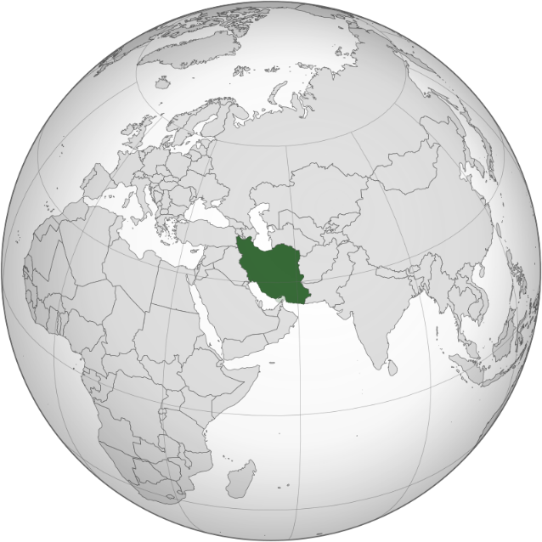

1. Introduction to Iran

Iran, officially the Islamic Republic of Iran, is a historic and culturally rich nation in Western Asia, often referred to as the “Cradle of Civilization.” With a history spanning 5,000 years, it is home to one of the world’s oldest continuous civilizations. Iran’s population of 88 million reflects a diverse blend of ethnicities, including Persians, Azeris, Kurds, and Baloch.

Capital: Tehran (a bustling metropolis of 15 million)

Official Language: Persian (Farsi)

Currency: Iranian Rial (IRR)

Historical Context: Iran, formerly known as Persia, was the heart of vast empires like the Achaemenid and Sassanian. After the 1979 Islamic Revolution, it became a theocratic republic governed by Shia Islamic principles.

2. Geography and Climate

Iran’s landscape is marked by dramatic contrasts:

Mountains: The Alborz and Zagros ranges frame the country, with Mount Damavand (5,610 m) as Asia’s highest volcano.

Deserts: The Dasht-e Kavir and Dasht-e Lut (one of Earth’s hottest places) dominate central Iran.

Caspian Coast: A lush, subtropical region in the north.

Climate: Arid to semi-arid, with cold winters and hot summers. The Caspian region enjoys moderate rainfall, while the south faces extreme heat.

Environmental Challenges: Water scarcity, air pollution (notably in Tehran), and desertification. Iran invests in reforestation and renewable energy.

3. Cultural Heritage

Iran’s culture is a tapestry of ancient traditions and Islamic influences:

Nowruz: The Persian New Year (March 21), a 13-day celebration rooted in Zoroastrianism, featuring the Haft-Seen table.

Poetry: Revered poets like Rumi, Hafez, and Ferdowsi shaped Persian literature.

Architecture: UNESCO sites like Persepolis and Isfahan’s Naqsh-e Jahan Square showcase intricate tilework and grandeur.

Cultural Highlights:

Cuisine: Kebabs, ghormeh sabzi (herb stew), and saffron-infused dishes.

Handicrafts: Persian carpets, miniature paintings, and turquoise jewelry.

Festivals: Chaharshanbe Suri (fire-jumping ritual) and Yalda Night (winter solstice).

4. Economy: Sanctions and Resilience

Iran has the 2nd-largest economy in the Middle East (GDP: ~$1.6 trillion), driven by:

Oil and Gas: 4th-largest oil reserves globally, but sanctions limit exports.

Agriculture: Pistachios, saffron (90% of global production), and dates.

Handicrafts: Persian carpets generate $500 million annually.

Economic Challenges: U.S. sanctions (post-2018 nuclear deal withdrawal), inflation (~40%), and youth unemployment (25%). Iran’s “Resistance Economy” focuses on self-sufficiency.

5. Fascinating Facts

a) Ancient Innovations

Yakhchāl: Ancient ice houses, an early refrigeration system using windcatchers.

Algebra: Persian scholar Al-Khwarizmi pioneered algebraic concepts in the 9th century.

b) Literacy and Education

Iran’s literacy rate is 88.7%, with free education up to university level. Women comprise over 60% of STEM graduates.

c) Nuclear Program

The 2015 JCPOA (Iran nuclear deal) aimed to limit uranium enrichment, but tensions persist post-U.S. withdrawal.

Additional Highlights:

Polo (Chogan): Invented in ancient Persia as a royal sport.

Qanat System: A 3,000-year-old underground irrigation network, now a UNESCO site.

6. Challenges and Progress

Iran faces international isolation, human rights criticisms, and environmental crises. However, advancements in science (e.g., nanotechnology), cinema (Oscar-winning films), and women’s education highlight its resilience.

Healthcare and Demographics:

Healthcare: Life expectancy: 75.8 years (men) and 79.6 years (women). Public hospitals serve 90% of the population.

Youth: 60% of the population is under 30, driving demands for social reform.

7. Education and Healthcare

Education: Iran has over 50 universities, including University of Tehran and Sharif University of Technology. The Konkur exam determines university admissions.

Healthcare: A hybrid system combining public clinics and private hospitals. Traditional medicine (e.g., herbal remedies) remains popular.

Conclusion

Iran’s blend of ancient heritage and modern ambition makes it a unique force in global culture and geopolitics. Despite challenges, its contributions to art, science, and philosophy continue to inspire.