Colombia: An Overview and Fascinating Facts

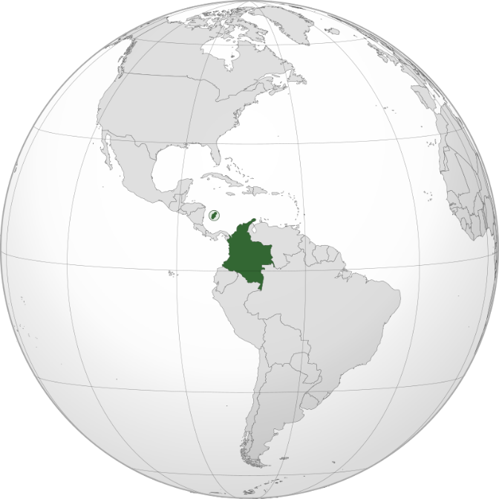

1. Introduction to Colombia

Colombia, officially the Republic of Colombia, is a vibrant nation in northwestern South America, celebrated for its biodiversity, coffee, and cultural richness. With 52 million people, it is the 2nd-most biodiverse country globally and a gateway to both the Amazon and the Andes.

Capital: Bogotá (a high-altitude metropolis of 8 million)

Official Language: Spanish

Currency: Colombian Peso (COP)

Historical Context: Colombia’s history spans Indigenous civilizations (e.g., Muisca, Tayrona), Spanish colonization (1538–1819), and a turbulent 20th century marked by civil conflict. The 2016 peace deal with FARC guerrillas ushered in a new era of stability.

2. Geography and Climate

Colombia’s geography is a tapestry of extremes:

Andes Mountains: Three parallel ranges (Cordilleras) divide the country, with peaks like Nevado del Ruiz (5,321 m).

Amazon Rainforest: Covers 35% of Colombia, teeming with jaguars, pink river dolphins, and Indigenous communities.

Caribbean and Pacific Coasts: Home to coral reefs, humpback whales (June–October), and Afro-Colombian culture.

Llanos: Vast eastern plains ideal for cattle ranching.

Climate: Tropical along coasts, temperate in highlands. No traditional seasons—rainfall defines “wet” and “dry” periods.

Environmental Challenges: Deforestation (lost 1.2 million hectares of Amazon forest since 2000), illegal mining, and coca cultivation. Colombia leads in bird species (1,950+), orchids (4,000+), and butterflies.

3. Cultural Heritage

Colombia’s culture blends Indigenous, African, and Spanish influences:

Festivals: Carnival of Barranquilla (UNESCO Intangible Heritage) and Medellín’s Flower Festival.

Music and Dance: Cumbia, vallenato, and salsa. Shakira and Juanes are global icons.

UNESCO Sites: Coffee Cultural Landscape, San Agustín Archaeological Park, and the walled city of Cartagena.

Cultural Highlights:

Cuisine: Bandeja paisa (meat platter), arepas (corn cakes), and aguardiente (anise-flavored liquor).

Art: Fernando Botero’s “chubby” sculptures and Gabriel García Márquez’s magical realism.

Indigenous Legacy: The Kogi and Wayuu peoples preserve ancient traditions.

4. Economy: Growth and Challenges

Colombia has the 4th-largest economy in Latin America (GDP: ~$343 billion), driven by:

Oil and Mining: Top exports include coal, emeralds (70% of global production), and coffee (3rd-largest producer).

Agriculture: Bananas, flowers (2nd-largest exporter), and avocados.

Tourism: 4.5 million visitors in 2023, drawn to Cartagena, Tayrona Park, and Medellín’s transformation.

Economic Challenges: Income inequality (Gini index: 51.5), rural poverty, and reliance on oil (40% of exports). The government promotes tech startups (“Calle del Silicon” in Medellín) and renewable energy.

5. Fascinating Facts

a) Coffee Cultural Landscape

A UNESCO World Heritage Site where traditional fincas (coffee farms) produce some of the world’s best Arabica beans.

b) Ciudad Perdida

The “Lost City” of the Tayrona civilization, older than Machu Picchu, hidden in the Sierra Nevada de Santa Marta.

c) Medellín’s Metrocable

A gondola system connecting hillside slums to the city center—a symbol of urban innovation post-drug cartel era.

Additional Highlights:

Chocó Bioregion: One of the rainiest places on Earth, with 12,000+ plant species.

Palenquera Women: Descendants of escaped slaves selling tropical fruits in Cartagena, speaking the creole language Palenquero.

6. Challenges and Progress

Colombia grapples with drug trafficking (coca production rose 13% in 2023), illegal armed groups, and displacement (6.9 million internally displaced people). However, the 2016 peace accord reduced violence by 50%, and cities like Medellín transformed from cartel hubs to tech hubs.

Education and Healthcare:

Education: Free public schooling until age 15; literacy rate: 95%. Top universities: Universidad de los Andes, National University of Colombia.

Healthcare: Ranked 22nd globally by WHO. Life expectancy: 77 years.

7. Education and Healthcare

Education: Colombia invests 4.5% of GDP in education, focusing on rural access and STEM. The Ser Pilo Paga program funds low-income students’ university tuition.

Healthcare: A mixed public-private system (EPS). Challenges include rural healthcare gaps, but vaccination rates exceed 90%.

Conclusion

Colombia’s journey from conflict to hope reflects its resilience. With unparalleled biodiversity, cultural vibrancy, and economic potential, it is redefining itself as a destination for adventure, innovation, and peace.