Russia: An Overview and Fascinating Facts

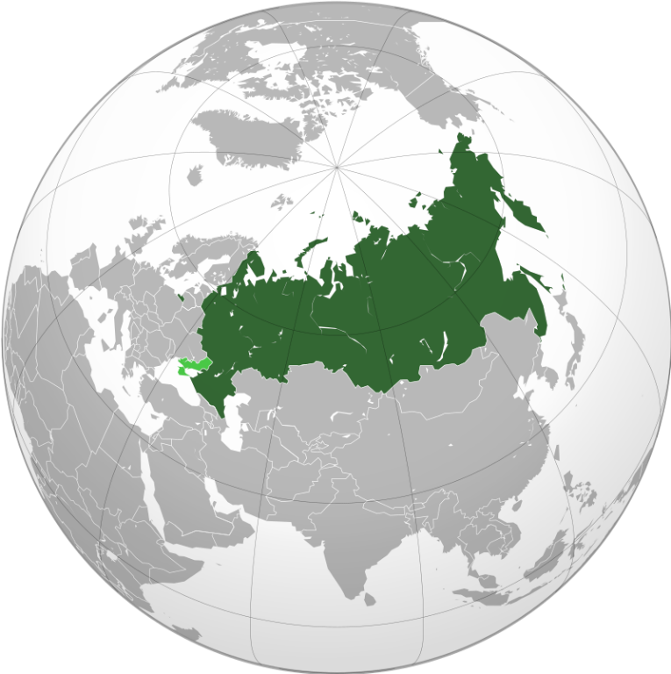

1. Introduction to Russia

Russia, officially the Russian Federation, is the largest country in the world, spanning 11 time zones across Eastern Europe and Northern Asia. With a population of 144 million, it is a land of extremes—vast tundras, dense forests, and a rich cultural tapestry shaped by Slavic, Turkic, and European influences.

Capital: Moscow (12.6 million residents, home to the Kremlin and Red Square)

Official Language: Russian

Currency: Russian Ruble (RUB)

Historical Context: Emerging from the medieval state of Kievan Rus’, Russia became an empire under the Romanovs (1613–1917). The 1917 Bolshevik Revolution led to the Soviet Union’s formation, which dissolved in 1991. Today, Russia is a federal semi-presidential republic with significant geopolitical influence.

2. Geography and Climate

Russia’s immense territory (17.1 million km²) includes:

Siberia: Frozen tundra, taiga forests, and Lake Baikal (the world’s deepest freshwater lake).

Ural Mountains: Divide Europe and Asia.

Caucasus Range: Home to Mount Elbrus (5,642 m), Europe’s highest peak.

Steppes: Vast grasslands in the south.

Climate: Arctic in the north, continental in central regions (harsh winters, hot summers), and subtropical near the Black Sea.

Environmental Challenges: Pollution from industry, deforestation, and permafrost thaw due to climate change. Russia holds 20% of global forests and aims to expand protected areas.

3. Cultural Heritage

Russia’s culture blends Orthodox Christian traditions, Soviet legacy, and ethnic diversity (over 190 ethnic groups):

Literature: Tolstoy, Dostoevsky, and Pushkin shaped global literary canon.

Arts: Iconic ballet (Bolshoi Theatre), classical music (Tchaikovsky, Rachmaninoff), and avant-garde art (Kandinsky).

Traditions: Maslenitsa (pancake festival), New Year celebrations, and Orthodox Christmas.

Cultural Highlights:

Cuisine: Borscht (beet soup), pelmeni (dumplings), blini (pancakes), and vodka.

Architecture: St. Basil’s Cathedral, Winter Palace, and Soviet-era constructivism.

UNESCO Sites: Kremlin and Red Square, Kizhi Pogost, Golden Mountains of Altai.

4. Economy: Resources and Resilience

Russia has the 6th-largest economy by PPP (GDP: ~$4.7 trillion), driven by:

Energy: World’s largest natural gas exporter, 2nd-largest oil producer.

Mining: Diamonds (Alrosa), nickel, and palladium.

Agriculture: Wheat (top global exporter), sunflower oil, and fisheries.

Economic Challenges: Sanctions (post-2014 Crimea annexation and 2022 Ukraine conflict), reliance on hydrocarbons, and brain drain. Efforts to boost tech (e.g., Skolkovo Innovation Center) and domestic production.

5. Fascinating Facts

a) Lake Baikal

The “Galápagos of Russia” holds 20% of Earth’s unfrozen freshwater and 3,700+ unique species, including the Baikal seal.

b) Trans-Siberian Railway

The world’s longest railway (9,289 km) connects Moscow to Vladivostok, crossing 8 time zones in 7 days.

c) Space Legacy

First satellite (Sputnik, 1957) and first human in space (Yuri Gagarin, 1961). Russia remains a key player in the ISS.

Additional Highlights:

Matryoshka Dolls: Symbol of Russian folk art.

Permafrost Cities: Norilsk and Yakutsk, among the coldest inhabited places.

Hermitage Museum: 3 million artifacts in St. Petersburg, once the Winter Palace.

6. Challenges and Progress

Russia faces international isolation, demographic decline (low birth rates), and political centralization. However, advancements in nuclear energy, Arctic exploration, and AI research highlight its scientific prowess.

Education and Healthcare:

Education: Free universal education; literacy rate: 99.7%. Top universities: Moscow State University, SPbU.

Healthcare: Life expectancy: 73 years. Public healthcare is underfunded, but medical research (e.g., Sputnik V COVID vaccine) is robust.

7. Education and Healthcare

Education: Emphasis on STEM; Russia ranks 4th globally in mathematics (PISA). State scholarships support international students.

Healthcare: Mixed system with mandatory insurance. Challenges include rural access and alcohol-related diseases.

Conclusion

Russia’s vast landscapes, cultural grandeur, and scientific achievements make it a nation of contradictions—both a bridge and a barrier between East and West. Balancing tradition with modernization, it remains a pivotal global actor.