Morocco: An Overview and Fascinating Facts

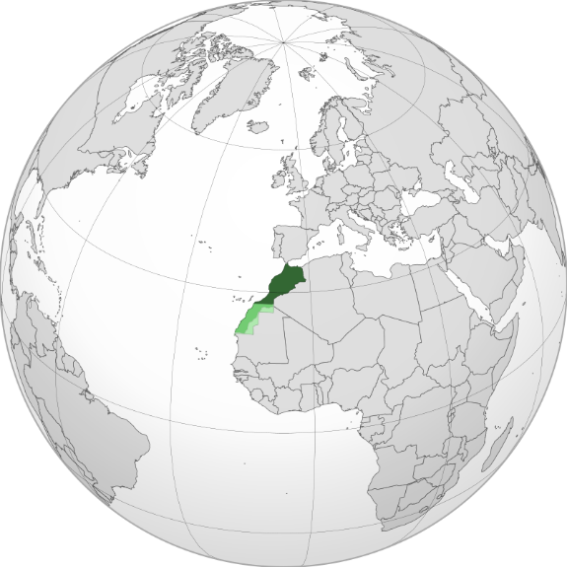

1. Introduction to Morocco

Morocco, officially the Kingdom of Morocco, is a captivating country in North Africa. Known for its rich history, cultural diversity, and strategic location, it bridges the African and European continents. With a population of 37 million, Morocco is a melting pot of Arab, Berber, and Mediterranean influences.

Capital: Rabat

Largest City: Casablanca (a bustling economic hub)

Official Languages: Arabic and Berber (Tamazight)

Currency: Moroccan Dirham (MAD)

Historical Context: Morocco gained independence from France in 1956 and is one of the oldest monarchies in the world, currently ruled by King Mohammed VI. The country has preserved its ancient traditions while embracing modernity.

2. Geography and Climate

Morocco’s geography is strikingly diverse:

Atlas Mountains: Stretching across the country, home to Mount Toubkal (4,167 m), North Africa’s highest peak.

Sahara Desert: Expansive dunes in the south, including the iconic Erg Chebbi (ideal image spot).

Coastlines: The Atlantic Ocean to the west and the Mediterranean Sea to the north.

Climate: Mediterranean in the north (hot summers, mild winters) and arid in the south. The Sahara region experiences extreme temperature fluctuations.

Natural Wonders:

Ouzoud Waterfalls: Cascading 110 meters in the Atlas Mountains.

Dades Valley: Known as the “Valley of a Thousand Kasbahs.”

3. Cultural Diversity

Morocco’s culture is a blend of Arab, Berber, and Andalusian heritage:

Berber Communities: Indigenous people with traditions dating back millennia, celebrated in festivals like the Imilchil Marriage Festival.

Arab Influence: Visible in architecture, language, and Islamic practices.

Andalusian Legacy: Reflected in music (e.g., Andalusian classical) and historic cities like Fes.

Religion: 99% Muslim, with small Jewish and Christian communities.

Cultural Highlights:

Cuisine: Tagine (slow-cooked stew), couscous, and mint tea are national staples.

Crafts: Intricate zellige (mosaic tilework), leather goods from Fes’ tanneries, and handwoven Berber carpets.

4. Economy: A Regional Leader

Morocco has the 5th-largest economy in Africa (GDP: ~$130 billion), driven by:

Agriculture: Leading exporter of phosphates (world’s largest reserves) and citrus fruits.

Tourism: Attracts over 13 million visitors annually to sites like Marrakech and the Sahara.

Renewable Energy: Home to the world’s largest solar farm, Noor Ouarzazate.

Economic Challenges: Unemployment (especially among youth), water scarcity, and reliance on agriculture vulnerable to climate change.

5. Fascinating Facts

a) Hollywood of Africa

Morocco’s landscapes have starred in films like Gladiator, Game of Thrones, and Lawrence of Arabia. The fortified village of Aït Benhaddou (add image) is a UNESCO site and a favorite filming location.

b) The Blue Pearl

Chefchaouen, a city in the Rif Mountains, is famous for its blue-painted streets and buildings, a tradition linked to Jewish refugees in the 1930s.

c) UNESCO Treasures

Medina of Fes: A labyrinthine medieval city and the world’s largest car-free urban zone.

Historic Rabat: Blends ancient ruins with French colonial architecture.

Additional Highlights:

Morocco is the only African country with both Atlantic and Mediterranean coastlines.

The University of Al Quaraouiyine in Fes, founded in 859 AD, is the oldest existing degree-granting university in the world.

6. Challenges and Progress

Morocco faces issues like poverty, rural-urban inequality, and migration pressures. However, its progressive reforms in women’s rights (e.g., 2004 Family Code) and renewable energy investments showcase its modernization efforts.

Education and Healthcare:

Education: Free and compulsory until age 15, with growing emphasis on vocational training.

Healthcare: Improved life expectancy (76 years) but disparities persist between urban and rural areas.

7. Education and Healthcare

Education: Morocco’s literacy rate has risen to 73%, though rural areas lag. Universities like Mohammed V University in Rabat are regional leaders.

Healthcare: The government aims to achieve universal health coverage by 2030, focusing on reducing maternal mortality and expanding insurance programs.

Conclusion

Morocco’s blend of ancient traditions and forward-thinking policies makes it a unique gem in North Africa. From the Sahara’s golden dunes to the vibrant souks of Marrakech, it captivates travelers and scholars alike.