Bangladesh: An Overview and Fascinating Facts

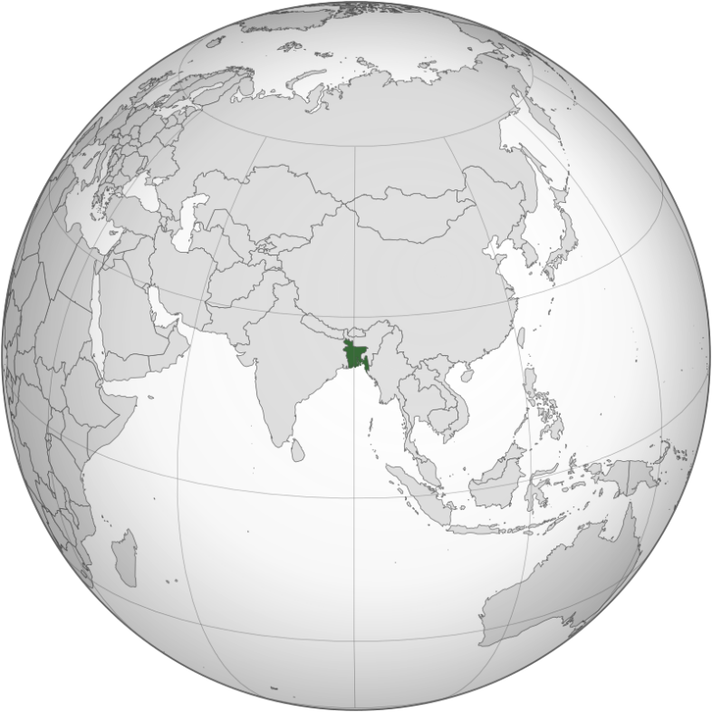

1. Introduction to Bangladesh

Bangladesh, officially the People’s Republic of Bangladesh, is a densely populated South Asian country nestled between India and Myanmar. Known as the “Land of Rivers,” it is celebrated for its lush landscapes, vibrant culture, and resilience. With 170 million people, it is the 8th most populous country globally and one of the most densely populated.

Capital: Dhaka (a megacity of over 21 million)

Official Language: Bengali (Bangla)

Currency: Bangladeshi Taka (৳)

Historical Context: Bangladesh gained independence from Pakistan in 1971 after a bloody liberation war. Today, it is a parliamentary democracy with a growing focus on economic and social development.

2. Geography and Climate

Bangladesh’s geography is dominated by the fertile Ganges-Brahmaputra Delta, the largest river delta in the world. Key features include:

Rivers: Over 700 rivers, including the Padma (Ganges), Jamuna (Brahmaputra), and Meghna.

Sundarbans: The world’s largest mangrove forest, home to the Royal Bengal Tiger (ideal image spot).

Cox’s Bazar: The longest natural sea beach (120 km) along the Bay of Bengal.

Climate: Tropical monsoon, with heavy rainfall (June–October) and frequent cyclones. Rising sea levels and flooding pose existential threats due to climate change.

Environmental Challenges: Bangladesh ranks among the most climate-vulnerable nations, facing river erosion, salinity intrusion, and displacement of coastal communities.

3. Cultural Diversity

Bangladesh’s culture is deeply rooted in Bengali traditions, with influences from Mughal, British, and indigenous heritage:

Language Movement: The 1952 protest for Bengali linguistic rights is commemorated globally as International Mother Language Day (UNESCO).

Festivals: Pohela Boishakh (Bengali New Year), Durga Puja, and Eid celebrations reflect religious harmony.

Arts: Baul folk music, traditional dance like Jatra, and Nobel laureate Rabindranath Tagore’s literary legacy.

Religion: 90% Muslim, 9% Hindu, and small Buddhist/Christian communities.

Cultural Highlights:

Nakshi Kantha: Intricately embroidered quilts symbolizing rural artistry.

Rickshaw Art: Colorfully decorated cycle rickshaws, a moving gallery of urban culture.

4. Economy: Rising Tiger of South Asia

Despite challenges, Bangladesh has achieved remarkable economic growth (GDP: ~$460 billion), driven by:

Garment Industry: The 2nd-largest exporter of ready-made garments (RMG) globally, employing 4 million workers (80% women).

Agriculture: Rice, jute (known as the “Golden Fiber”), and tea production.

Remittances: Over $20 billion annually from overseas workers.

Economic Challenges: Income inequality, infrastructure gaps, and reliance on low-wage industries. The government prioritizes digitalization and green energy projects.

5. Fascinating Facts

a) Sundarbans: A Unique Ecosystem

The Sundarbans (add image), a UNESCO World Heritage Site, spans Bangladesh and India. It shelters endangered species like the Royal Bengal Tiger and Irrawaddy dolphins.

b) Microfinance Revolution

Bangladesh pioneered microfinance through Grameen Bank (founded by Nobel laureate Muhammad Yunus), empowering millions of women entrepreneurs.

c) Language Martyrs

The Shaheed Minar monument in Dhaka honors students killed in the 1952 Language Movement, symbolizing Bengali identity.

Additional Highlights:

Bangladesh’s national symbol, the water lily (shapla), represents resilience.

The country has one of the world’s highest rates of NGO activity, focusing on poverty alleviation.

6. Challenges and Progress

Bangladesh faces poverty, political instability, and climate crises. However, strides in gender equality (female PM since 1991), healthcare (98% child vaccination rate), and GDP growth (6-7% annually) highlight its progress.

Education and Healthcare:

Education: Free primary education boosted literacy to 75%, but dropout rates remain high.

Healthcare: Life expectancy rose to 73 years, with success in reducing maternal mortality.

7. Education and Healthcare

Education: Bangladesh’s education system includes a 5-year primary cycle and emphasis on STEM. Universities like Dhaka University and BUET are regional leaders.

Healthcare: Community clinics and vaccination drives improved public health, though overcrowding in urban hospitals persists.

Conclusion

Bangladesh’s journey from “basket case” to a development model inspires the world. Its rich culture, economic grit, and fight against climate adversity make it a nation of relentless hope.