China: An Overview and Fascinating Facts

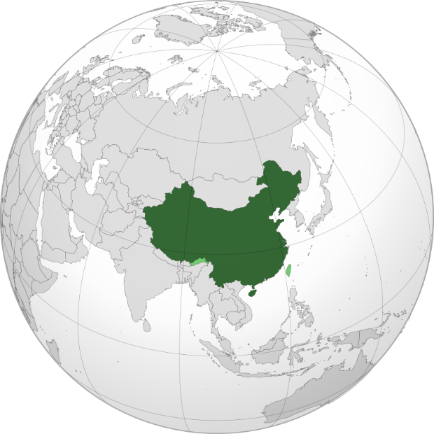

1. Introduction to China

China, officially the People’s Republic of China (PRC), is the world’s most populous country and a global superpower. With a civilization spanning over 5,000 years, it combines ancient traditions with cutting-edge modernity. Home to 1.4 billion people, it is the third-largest country by area and a dominant force in politics, economy, and culture.

Capital: Beijing

Largest City: Shanghai (a global financial hub)

Official Language: Mandarin (Putonghua)

Currency: Renminbi (RMB, ¥)

Historical Context: China’s history includes dynastic rule, revolutions, and rapid modernization. The Communist Party of China (CPC) has governed since 1949, transforming the nation into a socialist market economy.

2. Geography and Climate

China’s vast landscape is incredibly diverse:

Himalayas: Home to Mount Everest (shared with Nepal), the world’s highest peak.

Yangtze and Yellow Rivers: Cradles of Chinese civilization.

Gobi Desert: A vast arid region in the north.

Guilin Karst Mountains: Iconic limestone formations (ideal image spot).

Climate: Ranges from subarctic in the north (Harbin) to tropical in the south (Hainan). Monsoon rains dominate eastern regions, while the west is arid.

Environmental Challenges: Air pollution, soil erosion, and biodiversity loss due to industrialization. China is now the world’s largest investor in renewable energy.

3. Cultural Heritage

China’s culture is one of humanity’s oldest and most influential:

Ethnic Diversity: 56 recognized ethnic groups, including Han (92%), Zhuang, Uyghur, and Tibetan.

Philosophy: Confucianism, Taoism, and Buddhism shaped societal values.

Festivals: Lunar New Year, Mid-Autumn Festival, and Dragon Boat Festival.

Cultural Highlights:

Calligraphy and Painting: Revered arts symbolizing harmony and discipline.

Cuisine: Eight major regional styles (e.g., Sichuan, Cantonese), featuring dishes like Peking duck and dim sum.

Traditional Medicine: Practices like acupuncture and herbal remedies remain widely used.

4. Economy: The Global Engine

China has the world’s second-largest economy (GDP: ~$18 trillion), driven by:

Manufacturing: Produces 28% of global industrial output (e.g., electronics, textiles).

Technology: Giants like Huawei, Alibaba, and Tencent lead in 5G, AI, and e-commerce.

Belt and Road Initiative (BRI): A $1 trillion infrastructure project spanning 140+ countries.

Economic Challenges: Income inequality, an aging population, and trade tensions with the West.

5. Fascinating Facts

a) The Great Wall

Stretching 21,196 km, the Great Wall (add image) is a UNESCO World Heritage Site and one of the Seven Wonders of the Medieval World.

b) Innovations

China invented paper, gunpowder, the compass, and printing—the “Four Great Inventions” that shaped global history.

c) Megacities

Chongqing, with 32 million residents, is the world’s largest city by population. Shenzhen evolved from a fishing village to a tech metropolis in 40 years.

Additional Highlights:

Pandas: China’s national treasure, found only in Sichuan’s bamboo forests.

Terracotta Army: A 2,200-year-old collection of 8,000 clay soldiers guarding Emperor Qin’s tomb (add image).

6. Challenges and Progress

China faces criticism over human rights, censorship, and territorial disputes (e.g., South China Sea). However, its achievements in poverty reduction (800 million lifted since 1980) and space exploration (e.g., Chang’e lunar missions) are unparalleled.

Education and Healthcare:

Education: Free compulsory education for 9 years. Top universities include Tsinghua and Peking University.

Healthcare: Life expectancy rose from 35 (1949) to 77 years, though rural-urban disparities persist.

7. Education and Healthcare

Education: China’s Gaokao (college entrance exam) is the world’s toughest, with 10 million annual test-takers. STEM fields are prioritized.

Healthcare: A mixed public-private system; traditional and Western medicine coexist. The government aims for universal health coverage by 2030.

Conclusion

China’s blend of ancient wisdom and modern ambition makes it a cornerstone of global progress. From the Silk Road to AI, it continues to shape humanity’s future.