Egypt: An Overview and Fascinating Facts

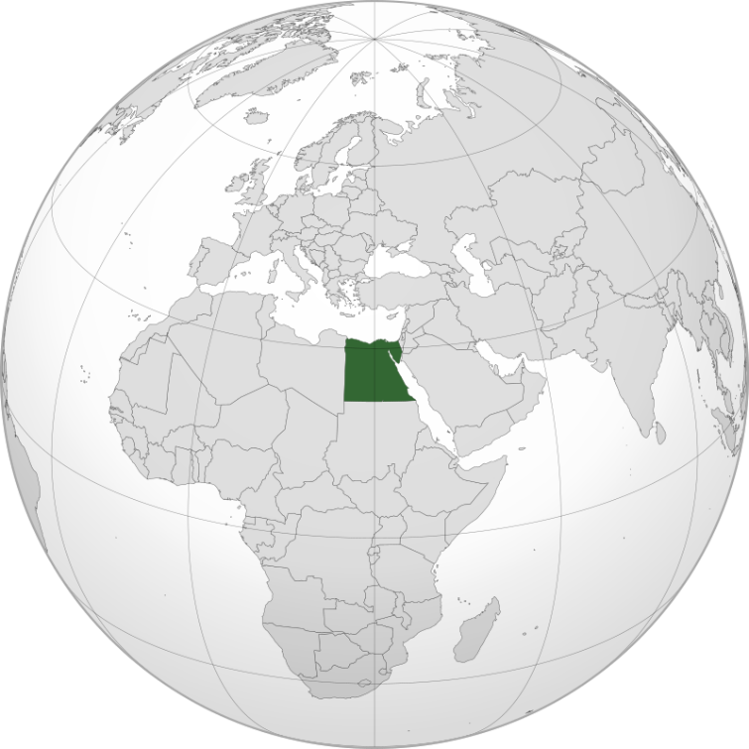

1. Introduction to Egypt

Egypt, officially the Arab Republic of Egypt, is a transcontinental country bridging Africa and Asia via the Sinai Peninsula. Known as the “Cradle of Civilization,” it boasts a history spanning over 5,000 years, with iconic monuments like the Pyramids of Giza and the Sphinx. With 112 million people, Egypt is the most populous Arab nation and a cultural, political, and economic leader in the Middle East and North Africa (MENA).

Capital: Cairo (home to 22 million residents)

Official Language: Arabic

Currency: Egyptian Pound (EGP)

Historical Context: Egypt’s ancient Pharaonic, Greco-Roman, and Islamic heritage has shaped global history. Modern Egypt gained independence from British rule in 1922 and is now a republic governed under a semi-presidential system.

2. Geography and Climate

Egypt’s landscape is dominated by the Nile River, the lifeline for 95% of its population. Key features include:

Sahara Desert: Covers 90% of Egypt, including the Western Desert and Libyan Desert.

Red Sea Coast: Renowned for coral reefs and resorts like Sharm El-Sheikh.

Nile Delta: Fertile agricultural region north of Cairo.

Climate: Arid, with hot summers and mild winters. The Nile Valley enjoys a temperate climate, while desert areas experience extreme heat.

Environmental Challenges: Water scarcity (97% reliant on the Nile), desertification, and rising sea levels threatening the Delta.

3. Cultural Heritage

Egypt’s culture blends ancient traditions, Arab-Islamic influences, and Mediterranean flair:

Ancient Legacy: Hieroglyphics, mummification, and gods like Ra and Isis.

Islamic Architecture: Mosques like Al-Azhar (970 CE) and Muhammad Ali’s Mosque in Cairo.

Coptic Christianity: 10% of Egyptians follow this ancient branch of Christianity.

Cultural Highlights:

Festivals: Sham El-Nessim (spring festival) and Ramadan celebrations.

Cuisine: Ful medames (fava beans), koshari (street food), and mahshi (stuffed vegetables).

Arts: Traditional music (e.g., Umm Kulthum) and Arabic calligraphy.

4. Economy: A Regional Powerhouse

Egypt has the 3rd-largest economy in Africa (GDP: ~$475 billion), driven by:

Suez Canal: Generates $9 billion annually, linking Europe and Asia.

Tourism: Attracts 15 million visitors yearly to sites like Luxor and the Red Sea.

Natural Gas: Major exporter, with the Zohr Field (Mediterranean) boosting production.

Economic Challenges: High public debt, youth unemployment (25%), and inflation. Egypt’s Vision 2030 aims to diversify into renewable energy and tech.

5. Fascinating Facts

a) The Pyramids of Giza

The Great Pyramid, built for Pharaoh Khufu (2600 BCE), is the last surviving Wonder of the Ancient World.

b) Medical Education

Egypt’s medical schools, like Alexandria University, combine modern training with ancient practices.

c) Arab Spring Legacy

The 2011 revolution ousted Hosni Mubarak, leading to political reforms and challenges.

Additional Highlights:

The Great Sphinx: A 4,500-year-old limestone marvel guarding the Giza Plateau.

Papyrus: Ancient Egyptians invented paper from this reed plant.

6. Challenges and Progress

Egypt faces poverty, political instability, and terrorism (e.g., Sinai insurgency). However, megaprojects like the New Administrative Capital and Benban Solar Park signal modernization.

Education and Healthcare:

Education: Free pre-university education, but overcrowding persists. Literacy: 72%.

Healthcare: Mixed public-private system; life expectancy: 72 years.

7. Education and Healthcare

Education: Al-Azhar University (970 CE) is among the world’s oldest. Modern institutions like Cairo University lead in STEM fields.

Healthcare: Government initiatives aim to expand insurance coverage, though rural areas lack resources.

Conclusion

Egypt’s timeless allure lies in its ability to harmonize ancient wonders with 21st-century ambitions. From the Nile’s banks to renewable energy ventures, it remains a beacon of resilience and innovation.