Algeria: An Overview and Fascinating Facts

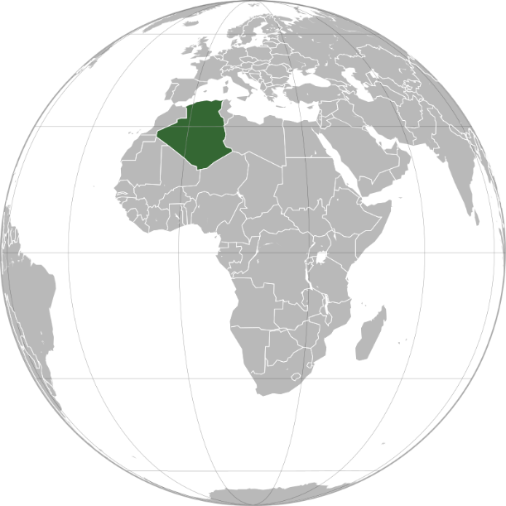

1. Introduction to Algeria

Algeria, officially the People’s Democratic Republic of Algeria, is the largest country in Africa and the 10th largest globally. Located in North Africa, it is a land of contrasts, blending Saharan dunes, ancient Roman ruins, and vibrant Arab-Berber culture. With 45 million people, Algeria is a key player in the Maghreb region and the Arab world.

Capital: Algiers (known as “Algiers the White” for its gleaming buildings)

Official Languages: Arabic and Berber (Tamazight)

Currency: Algerian Dinar (DZD)

Historical Context: Algeria gained independence from France in 1962 after a brutal eight-year war. Today, it is a republic with a strong presidential system, rich in natural resources and historical legacy.

2. Geography and Climate

Algeria’s geography is defined by:

The Sahara Desert: Covers 80% of the country, including the stunning Tassili n’Ajjer plateau (ideal image spot).

Atlas Mountains: Divide the northern fertile coast from the arid south.

Hoggar Mountains: Volcanic peaks in the Sahara, home to the iconic Assekrem hermitage.

Climate: Mediterranean along the coast (mild, rainy winters) and extreme desert heat in the Sahara.

Environmental Challenges: Desertification, water scarcity, and oil pollution. Algeria is investing in solar energy to combat climate change.

3. Cultural Heritage

Algeria’s culture is a fusion of Berber, Arab, French, and Mediterranean influences:

Berber Identity: The indigenous Amazigh people, celebrated through festivals like Yennayer (Berber New Year).

Islamic Traditions: Mosques like the Ketchaoua Mosque in Algiers reflect Ottoman and Moorish architecture.

French Legacy: Visible in urban design, cuisine, and bilingualism.

Cultural Highlights:

Music: Rai (popularized by Cheb Khaled), Andalusian classical, and traditional Berber folk.

Cuisine: Couscous, merguez (spicy sausage), and mint tea.

Crafts: Handwoven carpets, pottery, and silver jewelry.

4. Economy: Resource-Rich Nation

Algeria has the 4th-largest economy in Africa (GDP: ~$170 billion), driven by:

Hydrocarbons: Oil and gas account for 95% of exports (OPEC member).

Agriculture: Dates (world’s 5th-largest producer), olives, and citrus fruits.

Renewables: The Hassi R’Mel solar-gas hybrid plant pioneers green energy.

Economic Challenges: Over-reliance on oil, youth unemployment (30%), and import dependency. The government aims to diversify through tourism and tech.

5. Fascinating Facts

a) Ancient Roman Legacy

The Roman ruins of Djemila and Timgad (add image) are UNESCO World Heritage Sites, showcasing well-preserved theaters, temples, and mosaics.

b) Tassili n’Ajjer: Prehistoric Art Gallery

This UNESCO site features 15,000-year-old rock paintings depicting ancient Saharan wildlife and human rituals.

c) The Casbah of Algiers

A maze-like Ottoman-era citadel and UNESCO site, symbolizing resistance during Algeria’s independence struggle.

Additional Highlights:

Albert Camus: Nobel Prize-winning author born in Algeria, known for The Stranger.

National Liberation Front (FLN): Led the 1954–1962 revolution against French rule.

6. Challenges and Progress

Algeria faces political stagnation, corruption, and social unrest (e.g., the 2019–2020 Hirak protests). However, reforms in women’s rights (e.g., 2021 quota for female MPs) and renewable energy signal progress.

Education and Healthcare:

Education: Free and compulsory until age 16. Universities like University of Algiers are regional leaders.

Healthcare: Life expectancy: 77 years. Public hospitals face overcrowding, but vaccination rates are high.

7. Education and Healthcare

Education: Algeria’s literacy rate is 81%, with emphasis on STEM fields. The country hosts Africa’s largest library, the Bibliothèque Nationale d’Algérie.

Healthcare: Government-funded system covers 90% of the population, though rural areas lack specialists.

Conclusion

Algeria’s vast deserts, rich history, and cultural resilience make it a cornerstone of North Africa. Balancing its hydrocarbon wealth with sustainable development, it strives to empower its youth and preserve its heritage.