Angola: An Overview and Fascinating Facts

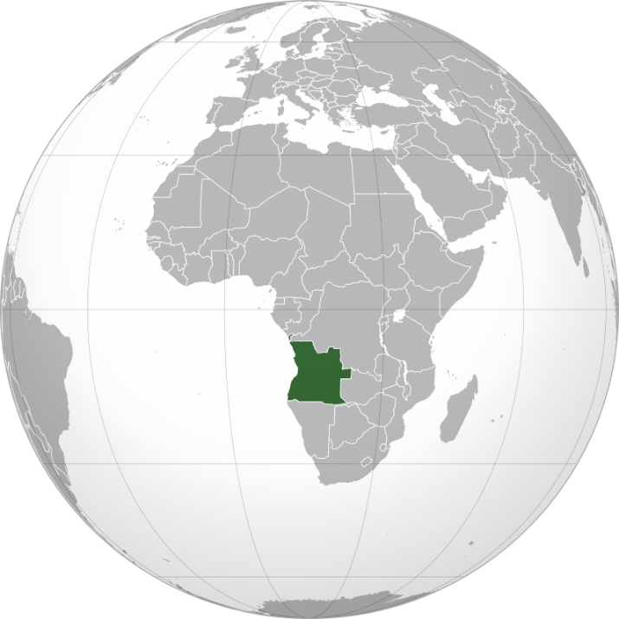

1. Introduction to Angola

Angola, officially the Republic of Angola, is a resource-rich nation in Southwest Africa, known for its dramatic landscapes and complex history. With 34 million people, it is the 7th-largest country in Africa and a former Portuguese colony. After gaining independence in 1975, Angola endured a 27-year civil war but has since emerged as a growing economic force.

Capital: Luanda (a bustling port city and one of the world’s most expensive cities for expats)

Official Language: Portuguese

Currency: Angolan Kwanza (AOA)

Historical Context: Angola’s history includes the Kongo Kingdom, Portuguese colonization (1483–1975), and a post-independence civil war (1975–2002). Today, it is a presidential republic focused on reconstruction and diversification.

2. Geography and Climate

Angola’s terrain is strikingly diverse:

Atlantic Coastline: Stretches 1,600 km, with Luanda and Benguela as key ports.

Central Plateau: Home to Mount Moco (2,620 m), the highest peak.

Namib Desert: Extends into southern Angola, merging with the Kunene River oasis.

Okavango Basin: A lifeline for wildlife in the southeast.

Climate: Tropical in the north, arid in the south, and temperate on the central plateau. The rainy season lasts from October to April.

Environmental Challenges: Deforestation, soil erosion, and landmines from the civil war. Angola is part of the Kavango-Zambezi Transfrontier Conservation Area (KAZA).

3. Cultural Heritage

Angola’s culture blends Bantu traditions, Portuguese influences, and Afro-Brazilian elements:

Ethnic Diversity: Over 90 ethnic groups, including Ovimbundu, Mbundu, and Bakongo.

Music and Dance: Kizomba and Semba (precursors to Brazilian samba) dominate festivals.

Art: Chokwe masks, wooden sculptures, and vibrant murals in Luanda.

Cultural Highlights:

Cuisine: Muamba de galinha (chicken stew), funje (cassava porridge), and palm wine.

Festivals: Carnival of Luanda (February) and National Heroes Day (September 17).

Religion: 40% Roman Catholic, 15% Protestant, and widespread traditional beliefs.

4. Economy: From War to Growth

Angola has Africa’s 3rd-largest oil reserves and is the 2nd-largest oil producer in Sub-Saharan Africa (GDP: ~$124 billion). Key sectors:

Oil and Diamonds: Account for 95% of exports.

Agriculture: Coffee, sisal, and bananas; potential for revival post-war.

Tourism: Emerging industry focused on national parks (e.g., Kissama) and beaches.

Economic Challenges: Over-reliance on oil, corruption, and poverty (32% live below the poverty line). The government’s 2023–2027 Development Plan prioritizes infrastructure and diversification.

5. Fascinating Facts

a) Kalandula Falls

The 2nd-largest waterfall in Africa (105 m tall), located on the Lucala River, is a breathtaking natural wonder (ideal image spot).

b) Giant Sable Antelope

Endemic to Angola, this critically endangered species is a national symbol, protected in Cangandala National Park.

c) Colonial Architecture

Luanda’s Fortaleza de São Miguel (1576) and Benguela’s pastel-colored buildings reflect Portuguese colonial heritage.

Additional Highlights:

Tundavala Gap: A dramatic 1,200-meter cliff offering panoramic views of the Huíla Plateau.

Bicauri National Park: A UNESCO Biosphere Reserve with elephants and rare birds.

6. Challenges and Progress

Angola struggles with inequality, corruption, and a youth unemployment rate of 56%. However, post-war reconstruction, anti-corruption campaigns, and investments in education signal hope.

Education and Healthcare:

Education: Free until 8th grade; literacy rate is 71%. Universities like Agostinho Neto University drive research.

Healthcare: Life expectancy: 61 years. HIV/AIDS and malaria remain critical issues, but vaccination rates are improving.

7. Education and Healthcare

Education: Angola’s education system is rebuilding after the war, with a focus on STEM and vocational training.

Healthcare: Public hospitals are underfunded, but partnerships with NGOs and China aim to improve access to care.

Conclusion

Angola’s journey from conflict to recovery highlights its resilience. With vast natural wealth, cultural richness, and untapped potential, it stands at a crossroads of opportunity.