Ecuador: An Overview and Fascinating Facts

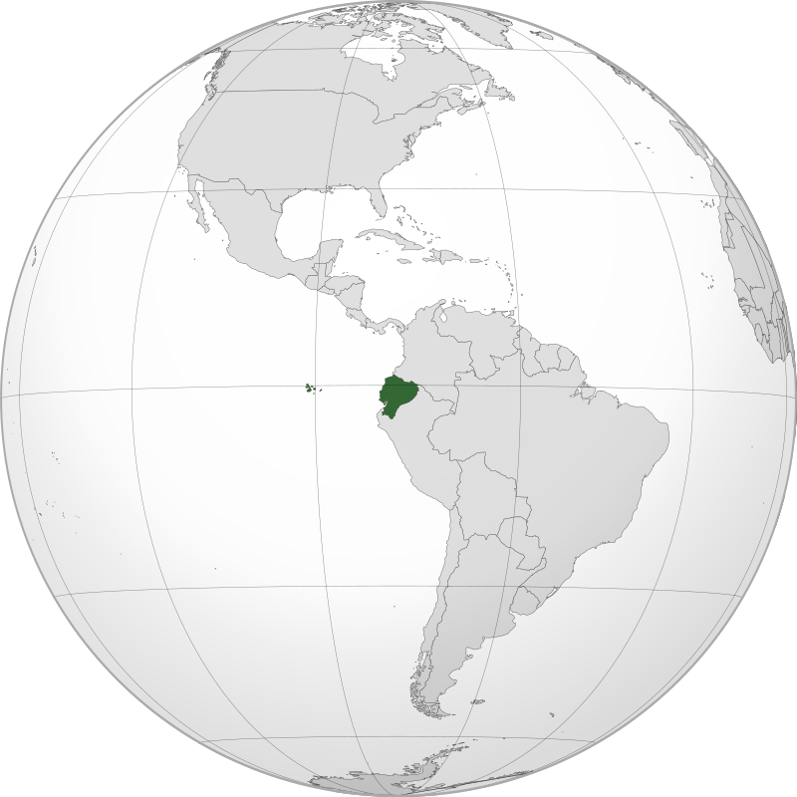

1. Introduction to Ecuador

Ecuador, officially the Republic of Ecuador, is a biodiverse nation straddling the equator on South America’s Pacific coast. Known as the “country of four worlds,” it encompasses the Galápagos Islands, Andean highlands, Amazon rainforest, and coastal plains. With 18 million people, Ecuador is a multicultural society blending Indigenous, Spanish, and Afro-Ecuadorian heritage.

Capital: Quito (a UNESCO World Heritage Site at 2,850 m altitude)

Largest City: Guayaquil (a bustling port)

Official Languages: Spanish, Kichwa (Quechua)

Currency: US Dollar (USD)

Historical Context: Ecuador was part of the Inca Empire before Spanish colonization (1534). It gained independence in 1830 and is now a democratic republic with progressive environmental policies.

2. Geography and Climate

Ecuador’s geography is divided into four distinct regions:

The Andes: Home to snow-capped volcanoes like Cotopaxi (5,897 m) and fertile valleys.

The Amazon Basin: Covers 40% of the country, rich in biodiversity.

The Coast: Tropical beaches and agricultural plains (banana, cocoa).

Galápagos Islands: A volcanic archipelago famed for unique wildlife (ideal image spot).

Climate: Varies by region—temperate in the Andes, tropical in the Amazon and coast. The Galápagos have a subtropical climate.

Environmental Challenges: Deforestation, oil extraction in the Amazon, and plastic pollution. Ecuador’s 2008 constitution grants rights to nature, a global first.

3. Cultural Heritage

Ecuador’s culture reflects Indigenous, colonial, and Afro-descendant influences:

Indigenous Roots: 25% of the population identifies as Indigenous (Kichwa, Shuar, etc.).

Festivals: Inti Raymi (Inca sun festival), Carnival of Guaranda, and Day of the Dead.

Arts: Traditional Andean music (panpipes, charango), Otavalo textiles, and Tagua nut carvings.

Cultural Highlights:

Cuisine: Ceviche (coastal seafood), locro de papa (potato soup), and chocolate (Ecuador is a top cocoa exporter).

UNESCO Sites: Quito’s colonial center, Cuenca’s historic architecture, and the Qhapaq Ñan (Inca road system).

4. Economy: Challenges and Opportunities

Ecuador’s economy (GDP: ~$115 billion) relies on:

Oil: Largest export, but controversial due to Amazon drilling.

Agriculture: Bananas (world’s top exporter), roses, and shrimp.

Tourism: Galápagos Islands attract 275,000 visitors annually.

Economic Challenges: Dollarization limits monetary policy, income inequality, and reliance on imports. Recent investments focus on renewable energy and ecotourism.

5. Fascinating Facts

a) Galápagos Islands

A UNESCO site where Charles Darwin developed his theory of evolution. Home to giant tortoises, marine iguanas, and blue-footed boobies (add image).

b) Middle of the World

Ecuador’s capital, Quito, lies near the equator. Visit the Mitad del Mundo monument, where you can stand in both hemispheres.

c) Yasuní National Park

One of Earth’s most biodiverse areas, with 100,000 insect species per hectare. Oil reserves beneath the park spark conservation debates.

Additional Highlights:

Chimborazo: Ecuador’s highest peak (6,263 m), the farthest point from Earth’s center due to equatorial bulge.

Panama Hat: Despite the name, these hats originated in Ecuador.

6. Challenges and Progress

Ecuador faces political instability, corruption, and crime. However, strides in conservation (e.g., banning oil drilling in Yasuní-ITT) and Indigenous rights (e.g., land titling) mark progress.

Education and Healthcare:

Education: Free and compulsory until age 14. Literacy rate: 93%.

Healthcare: Public system covers 80% of the population; life expectancy: 77 years.

7. Education and Healthcare

Education: Universities like Universidad San Francisco de Quito emphasize environmental science. Bilingual education (Spanish-Kichwa) promotes Indigenous inclusion.

Healthcare: Government clinics serve rural areas, but urban centers have better facilities. Traditional herbal medicine remains widespread.

Conclusion

Ecuador’s unparalleled biodiversity, cultural richness, and pioneering environmental policies make it a microcosm of global challenges and opportunities. From the Galápagos to the Amazon, it embodies the delicate balance between progress and preservation.