**MINISTRY OF EDUCATION AND SCIENCE**

**OF THE RUSSIAN FEDERATION**

**SOUTHERN FEDERAL UNIVERSITY**

I. I. Vorovich Institute of Mathematics, Mechanics and Computer Science

Department of … (for example, Department of Informatics and Computational Experiment or Department of Algebra and Discrete Mathematics)

for example, Оффеи Эндрю (Andrew Offei )

student’s full name in Russian (in Russian and in English)

ESSAY TITLE

(in Russian and in parentheses in English)

**ESSAY (Coursework)**

**Code and Title of the subject area** 02.03.02 — Theoretical computer science and information technologies (Фундаментальная информатика и информационные технологии)

**Scientific supervisor -**

for example, ст. преп. Майер Светлана Федоровна

(with an academic degree)

Rostov-on-Don – 2026

List of contents

Generate an automatic table of contents (after the paper is written):

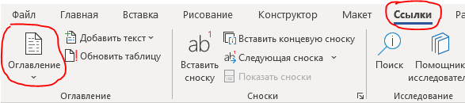

In order to update the table of contents, including all the document headers along with page numbers, it is enough to go to any line of the existing table of contents and press the **F9** key.

CONTENTS

List of contents 2

Problem Statement for ESSAY Paper 4

Introduction 5

Chapter 1. Research area 6

Chapter 2. Literature review 7

2.1. (if needed) The title of subchapter 7

2.2. (if needed) The title of subchapter 7

Conclusion 8

References 9

HOW to add References (you should delete this chapter) 10

Formatting Requirements (you should delete this chapter) 11

Problem Statement for ESSAY Paper

The objectives defined by your scientific supervisor.

Scientific supervisor _________________________/ /

Introduction

The introduction length is about 1 page.

In the model of an essay, the introduction and conclusion do similar things. They briefly introduce / summarize the topic and explain how the question or issue will be answered / has been answered. This is done through a sentence (known as the ‘paper statement’) that directly addresses or answers the essay topic. A paper statement is the main point of an essay. It summarizes the main aim of the essay and tells the reader what to expect in terms of an answer to the essay question or to outline the main point being made.

Be specific about the topic of the paper, introduce the background.

**Example**: This essay outlines the most commonly proposed initiatives for addressing climate change and argues that to address this issue both practical and political solutions must be found. …

You can include some of these:

(a) Relevant background information (briefly)

(b) Purpose or aim of the paper



Chapter 1. Research area

The length of this section is about 1-3 pages.

The research area chapter should address three questions: What, why, and how? To some extent, it repeats the introduction. After finishing the introduction, the reader should know what the paper is about, and after this Research area chapter he should know *why* it is worth reading, and *how* you’ll build your arguments.

**What?** Be specific about the topic of the paper, introduce the background, and define key terms or concepts.

**Why?** This is the most important part of the essay. Try to provide brief answers to the following question: What important issues does your essay help define or answer?

**How?** To let the reader know what to expect from the rest of the paper, the research area chapter should include a “map” of what will be discussed.

The section should generally be written mostly in **passive voice** and **impersonal style**.

You can include some of these:

(a) Definition of key terms, if needed

(b) Relevant background information (be more specific in comparison with introduction section)

(c) Review of work by other writers on the topic

Chapter 2. Literature review

The length of this chapter is about 5-8 pages (total size with subchapters).

## 2.1. (if needed) The title of subchapter

This is the main part of the paper. It can be divided into some subchapters if it is needed.

Here it is necessary to present the found description of what your paper is dedicated to: it can be programming language / program / database / resource / method, etc.. You should find the materials from journals, books, reports and other sources available via Internet (reliable scientific resources can be found here: <https://sites.google.com/view/recursostextosacademicos/academic-search-engines>). Don’t forget to add these resources to the **References** section of the paper.

For IT program the **technology stack** should be described here as well. It is better to add some advantages or disadvantages of using it. It is preferred if some figures or code snippets are added in this chapter.

You can include some of these:

(a) detailed description of what your paper is dedicated to

(b) advantages or disadvantages of using of what your paper is dedicated to

(c) figures / code snippets / schemas / formulas

**Example of inserting references**:

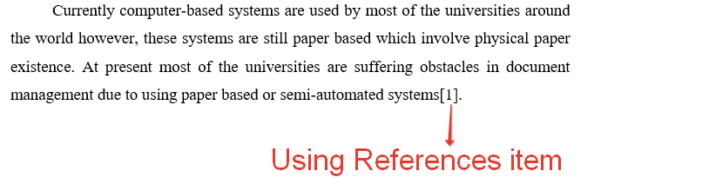

## 2.2. (if needed) The title of subchapter

…

Conclusion

The length of this section is about 1 page.

In your essay’s conclusion section, you summarize the points you made and bring your argument to its logical conclusion. Because your reader is now familiar with your essay, the summary in your conclusion section can be more direct and conclusive than the one in your intro section or **Problem Statement**.

You can include some of these:

(a) A statement showing how your aim has been achieved.

(b) A short review of the main points of your study.

(d) Some suggestions for further research.

References

1. …
2. …
3. Etc.

HOW to add References (you should delete this chapter)

As part of the evidence you provide for each of your topic sentences, you draw on ideas from a range of sources (These include materials from journals, books, reports and other sources, both hard copy materials as well as those available digitally via the internet).

The list of references should contain the names of the books, articles, and electronic resources used in the order of their citation.

The main text should contain links to all the items from the list.

For example:



For electronic resources, the name must be indicated, a full link to the web-document is provided and the date of application is indicated.

**Example**:

1. *ФИИТ web-site. – URL: http://it.mmcs.sfedu.ru (date of request 18.02.2020).*
2. *Aho A. V., Ullman J. D. The theory of parsing, translation, and compiling. Vol. 1. Parsing. – Prentice Hall, 1972.*
3. *Jiang T., Ravikumar B. Minimal NFA problems are hard // SIAM J. Comput. 1993, No. 22 (6). – P. 1117–1141.*

Formatting Requirements (you should delete this chapter)

The total length of an essay is about 12-20 pages.

**Headings**

Level 1 headings : centered, bold, title cased.

Level 2 headings : centered, bold.

When using the provided template in Microsoft Word, you can use the standard style called *Level 1 heading* or *Level 2 heading*.

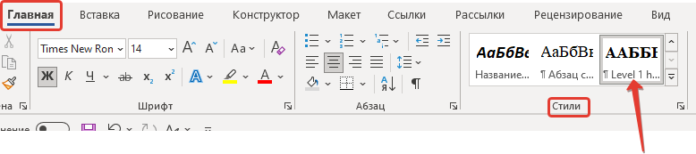

**Main text:**

The main guidelines for formatting a paper are as follows:

* Use a standard font like 14 pt Times New Roman or Computer Modern.
* Apply 1.5 line spacing.
* Indent every new paragraph 1.25 sm.
* Text-align – justify.
* Set 3 sm page left-margin, 1.5 sm page right-margin, 2 sm page top and bottom margins.

Mathematical formulas should be typed in formula editors.

All **tables, figures, diagrams**, and other objects inserted into the text must be numbered, captioned, and centered, and there must be a link to them in the text (Fig. 1). To add captions to diagrams, figures, and tables, when using the provided template in Microsoft Word, you can use the standard styles called *Figure Caption*, and *Table caption*.

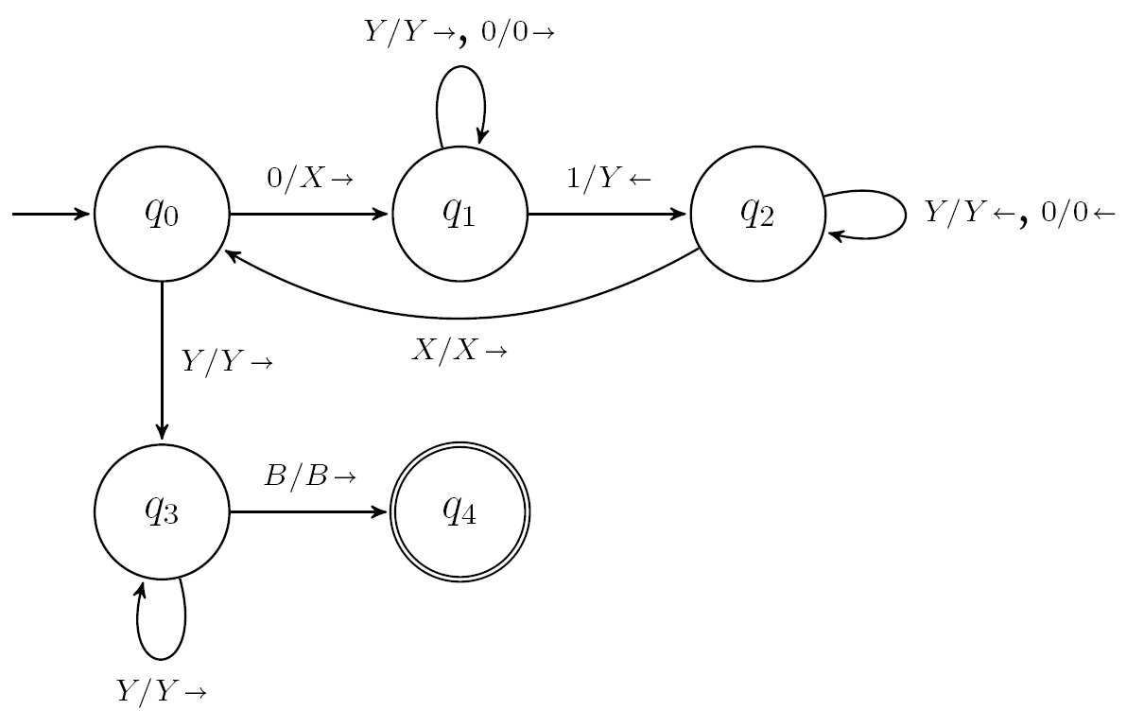

1. Turing Machine Transition Diagram

It is important that you refer to each figure or inserted object at least once in the main body of your essay:

Figure 1 presents Turing Machine Transition Diagram.

**Fragments of code (code snippets):**

* Use a font like 12 pt Courier New.
* Apply 1 line spacing.
* Text-align – left-side.
* Must be numbered, titled.

When using the provided template in Microsoft Word, you can use the standard styles called *Code snippet* and *Code caption*..

Example:

1. Example of a simple C++ program

#include <iostream>

int main()

{

std::cout << "Hello world!" << std::endl;

}

The size of fragments of the code should not exceed half a page.

To use the **lists** when using the provided template in Microsoft Word, you can use the standard styles called *Marked list* and *Numbered list*.

It should be noted that when a new numbered list is added to the text, the numbering of items will continue in it. To start numbering again, go to the first item of the new list and click mouse right button - "Start again from 1" (Начать заново с 1) from the context menu.

To explicitly break the page, a combination of Ctrl + Enter is provided. It should be borne in mind that the "Level 1 Heading" style provides an automatic transition to a new page for each section of the first level.