**MINISTRY OF EDUCATION AND SCIENCE**

**OF THE RUSSIAN FEDERATION**

**SOUTHERN FEDERAL UNIVERSITY**

I. I. Vorovich Institute of Mathematics, Mechanics and Computer Science

for example, Department of Informatics and Computational Experiment

for example, Оффеи Эндрю (Andrew Offei )

student’s full name in Russian (in Russian and in English)

**THESIS TITLE**

(in English, and in parentheses in Russian)

**RESEARCH PAPER**

**Code and Title of the subject area** 02.03.02 - Theoretical computer science and information technologies (Фундаментальная информатика и информационные технологии).

**Scientific supervisor -**

Your Scientific supervisor’s name and rank

Admitted to thesis presentation (Допущено к защите):  
the head of the program (руководитель направления)______________ / Майер С. Ф. /

Rostov-on-Don – 2026

List of contents

Generate an automatic table of contents (after the paper is written). In Microsoft word:

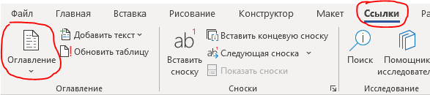

In order to update the table of contents, including all the document headers along with page numbers, it is enough to go to any line of the existing table of contents and press the **F9** key.

CONTENTS

Contents 2

Problem Statement for Research Paper 4

Introduction 5

Chapter 1. Literature review 6

1.1. The title of subchapter (if needed) 6

1.2. The title of subchapter (if needed) 6

1.3. The title of subchapter (if needed) 6

Chapter 2. Methodology and Research Results 7

2.1. The title of subchapter 7

2.2. The title of subchapter 8

2.3. The title of subchapter (if needed) 8

2.4. The title of subchapter (if needed) 8

Conclusion 9

References 10

Appendix (if needed) 11

Formatting Requirements 12

Problem Statement for Research Paper

The objectives defined by your scientific supervisor.

Scientific supervisor _________________________/ /

Introduction

The introduction length is about 2-3 pages (400-800 words).

In the model of a thesis, the introduction and conclusion do similar things. They briefly introduce / summarize the topic and explain how the question or issue will be answered/has been answered. This is done through a sentence (known as the ‘thesis statement’) that directly addresses or answers the thesis topic.

Be specific about the topic of the paper, introduce the background. A thesis statement must be specified here. A thesis statement is the main point of a thesis. It summarizes the main aim of the thesis and tells the reader what to expect in terms of an answer to the thesis question (if it is given as a question) or to outline the main point being made.

The Introduction should address three questions: What, why, and how? After finishing the introduction, the reader should know *why* it is worth reading, and *how* you’ll build your arguments.

**What?** Be specific about the topic of the paper, introduce the background, and define key terms or concepts.

**Why?** This is the most important, but also the most difficult, part of the thesis. Try to provide brief answers to the following questions: What is useful and new a resource / program / method of work can provide? What important issues does your thesis help define or answer?

**How?** To let the reader know what to expect from the rest of the paper, the research area section should include a “map” of what will be discussed.

**Example**: This research paper outlines the most commonly proposed initiatives for addressing climate change and argues that to address this issue both practical and political solutions must be found. …

You can include some of these:

(a) Definition of key terms, if needed

(b) Relevant background information (briefly)

(d) Purpose or aim of the paper

Chapter 1. Literature review (potential technology stack)

## 1.1. The title of subchapter (if needed)

The length of this chapter is about 7-10 pages or 30% of total text length (total size with subchapters).

This section can be divided into some subchapters if it is needed.

Here it is necessary to present the found description of the program / database / resource / method (you should find the materials from journals, books, reports and other sources available via Internet; don’t forget to add these resources to the **Using** **References**).

The basics that should be presented here:

* Give definitions of basic concepts.
* Provide background or summarize existing research.
* Position your own approach.

For IT direction a potential **technology stack** should be described here as well.

You can include some of these:

(a) Relevant background information (in detail)

(b) Review of work by other writers on the topic

**Example**: 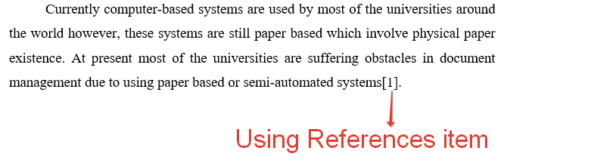

## 1.2. The title of subchapter (if needed)

…

## 1.3. The title of subchapter (if needed)

…

Chapter 2. Case study (Methodology and Research Results)

The length of this chapter is about 12-15 pages or 50% of total text length (total size with subchapters).

This section must be divided into some subchapters.

It is preferred if some figures or code snippets are added in this chapter.

## 2.1. The title of subchapter

In your thesis or dissertation, you will have to discuss the methods you used to do your research. The **Case Study chapter** explains what you did and how you did it, allowing readers to evaluate the reliability and validity of the research. It should include:

* detailed descriptions of methods and algorithms for solving problems (how the data was collected and analyzed): proofs of theorems, methods of carrying out experiments, justifications of correctness of algorithms, etc.;
* description of the development tools (programming languages, databases, frameworks, etc.) or materials that were used in the research; your rationale for choosing these tools (must be written in passive voice, impersonal style).

The section should generally be written in the [**past tense**](https://www.scribbr.com/academic-writing/tense-tendencies/)andusing **passive voice** and **impersonal style**.

Once you’ve finished collecting and analyzing your data, you can begin writing up the **results**. This is where you report the main findings of your research. It should include:

* descriptions of the developed programs/services, including samples of screen forms and code fragments;
* theoretical results (results of qualitative research or quantitative research) and/or empirical research results.

All relevant results should be reported concisely and objectively in a logical order. You may use tables, graphs, code snippets and figures to illustrate specific findings. Give your tables and figures clear, descriptive titles and labels so the reader can easily understand what is being shown.

You can include some of these:

1. Your research methods
2. Detailed algorithm for obtaining results and how you achieved them

(c) Any limitations you imposed

## 2.2. The title of subchapter

…

## 2.3. The title of subchapter (if needed)

…

## 2.4. The title of subchapter (if needed)

…

Conclusion

The length of this section is about 1-2 pages (150-300 words).

In your paper’s conclusion chapter, you summarize the points you made and bring your argument to its logical conclusion. Because your reader is now familiar with your thesis, the summary in your conclusion chapter can be more direct and conclusive than the one in your Problem Statement and Introduction sections.

You can include some of these:

(a) A statement showing how your aim has been achieved.

(b) A discussion of the implications of your research.

(c) A short review of the main points of your study.

(d) Some suggestions for further research.

(e) The limitations of your study.

(f) Comparison with the results of similar studies.

References

As part of the evidence you provide for each of your topic sentences, you draw on ideas from a range of sources (These include materials from journals, books, reports and other sources, both hard copy materials as well as those available digitally via the internet).

The list of references should contain the names of the books, articles, and electronic resources used in the order of their citation.

The main text should contain links to all the items from the list. For example:



For electronic resources, the name must be indicated, a full link to the web-document is provided and the date of application is indicated.

**Example**:

1. *ФИИТ web-site. – URL: http://it.mmcs.sfedu.ru (date of request 18.02.2020).*
2. *Aho A. V., Ullman J. D. The theory of parsing, translation, and compiling. Vol. 1. Parsing. – Prentice Hall, 1972.*
3. *Jiang T., Ravikumar B. Minimal NFA problems are hard // SIAM J. Comput. 1993, No. 22 (6). – P. 1117–1141.*

Appendices (if needed)

An appendix is a useful tool for providing additional information in a dissertation. You can use appendices to make sure your paper is not too long, avoid disrupting the text with a lot of tables and figures, and add background information on your topic.

Start each appendix on a new page and assign it both a number and a clear title, such as “Appendix 1. A fragment of code to connect to database”.

It is important that you refer to each appendix at least once in the main body of your paper:

Appendix 1 presents the code to make a connection with MySQL database.

Formatting Requirements

The total length of a paper is about 15-20 pages.

**Headings**

Level 1 headings : centered, bold, title cased.

Level 2 headings : centered, bold.

When using the provided template in Microsoft Word, you can use the standard style called *Level 1 heading* or *Level 2 heading*.

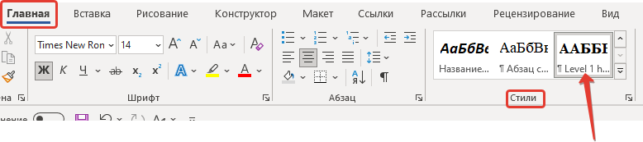

**Main text:**

The main guidelines for formatting a paper are as follows:

* Use a standard font like 14 pt Times New Roman or Computer Modern.
* Apply 1.5 line spacing.
* Indent every new paragraph 1.25 sm.
* Text-align – justify.
* Set 3 sm page left-margin, 1.5 sm page right-margin, 2 sm page top and bottom margins.

Mathematical formulas should be typed in formula editors.

All **tables, figures, diagrams**, and other objects inserted into the text must be numbered, captioned, and centered, and there must be a link to them in the text (Fig. 1). To add captions to diagrams, figures, and tables, when using the provided template in Microsoft Word, you can use the standard styles called *Figure Caption*, and *Table caption*.

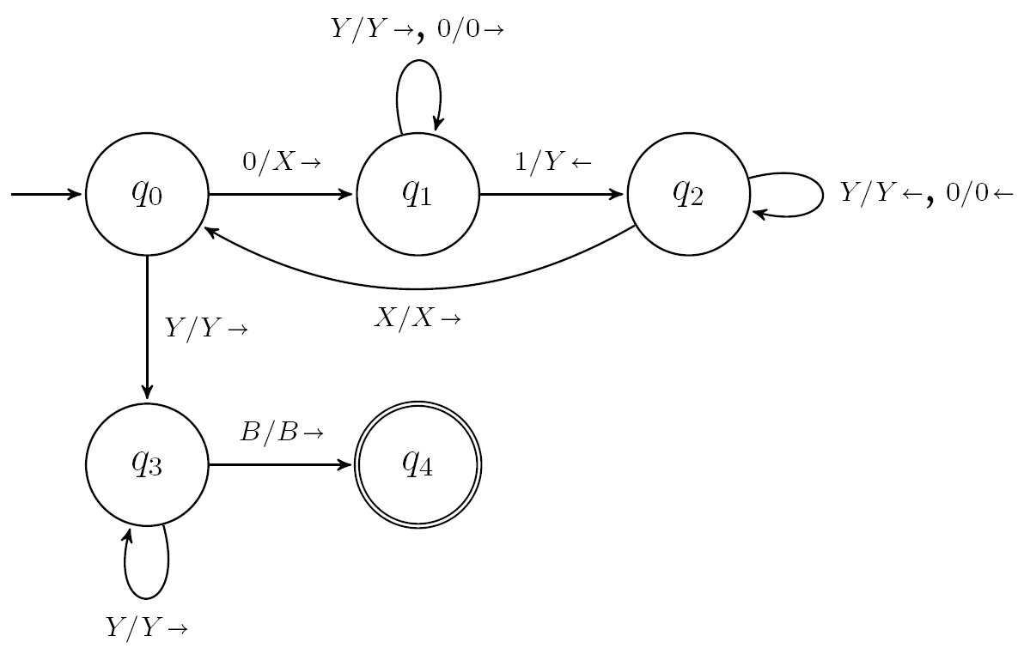

1. Turing Machine Transition Diagram

It is important that you refer to each figure or inserted object at least once in the main body of your paper:

Figure 1 presents Turing Machine Transition Diagram.

**Fragments of code (code snippets):**

* Use a font like 12 pt Courier New.
* Apply 1 line spacing.
* Text-align – left-side.
* Must be numbered, titled.

When using the provided template in Microsoft Word, you can use the standard styles called *Code snippet* and *Code caption*..

Example:

1. Example of a simple C++ program

#include <iostream>

int main()

{

std::cout << "Hello world!" << std::endl;

}

The size of fragments of the code should not exceed half a page. Larger fragments should be placed in the appendix to the paper.

To use the **lists** when using the provided template in Microsoft Word, you can use the standard styles called *Marked list* and *Numbered list*.

It should be noted that when a new numbered list is added to the text, the numbering of items will continue in it. To start numbering again, go to the first item of the new list and click mouse right button - "Start again from 1" (Начать заново с 1) from the context menu.

To explicitly break the page, a combination of Ctrl + Enter is provided. It should be borne in mind that the "Level 1 Heading" style provides an automatic transition to a new page for each section of the first level.